DNS
An application layer protocol defines how the application processes running on different systems; pass the messages to each other.
- DNS stands for Domain Name System.
- DNS is a directory service that provides a mapping between the name of a host on the network and its numerical address.
- DNS is required for the functioning of the internet.
- Each node in a tree has a domain name, and a full domain name is a sequence of symbols specified by dots.
- DNS is a service that translates the domain name into IP addresses. This allows the users of networks to utilize user-friendly names when looking for other hosts instead of remembering the IP addresses.
- For example, suppose the FTP site at EduSoft had an IP address of 132.147.165.50, most people would reach this site by specifying ftp.EduSoft.com. Therefore, the domain name is more reliable than IP address.
DNS is a TCP/IP protocol used on different platforms. The domain name space is divided into three different sections: generic domains, country domains, and inverse domain.
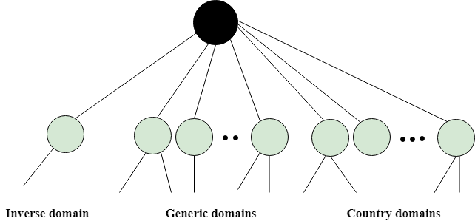

Generic Domains
- It defines the registered hosts according to their generic behavior.
- Each node in a tree defines the domain name, which is an index to the DNS database.
- It uses three-character labels, and these labels describe the organization type.
Label | Description
aero | Airlines and aerospace companies
biz | Businesses or firms
com | Commercial Organizations
coop | Cooperative business Organizations
edu | Educational institutions
gov | Government institutions
info | Information service providers
int | International Organizations
mil | Military groups
museum | Museum & other nonprofit organizations
name | Personal names
net | Network Support centers
org | Nonprofit Organizations
pro | Professional individual Organizations
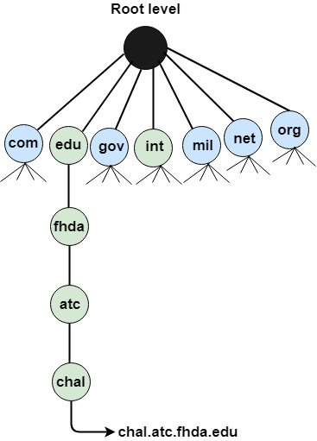

Country Domain
The format of country domain is same as a generic domain, but it uses two-character country abbreviations (e.g., us for the United States) in place of three character organizational abbreviations.

Inverse Domain
The inverse domain is used for mapping an address to a name. When the server has received a request from the client, and the server contains the files of only authorized clients. To determine whether the client is on the authorized list or not, it sends a query to the DNS server and ask for mapping an address to the name.

Working of DNS
- DNS is a client/server network communication protocol. DNS clients send requests to the. server while DNS servers send responses to the client.
- Client requests contain a name which is converted into an IP address known as a forward DNS lookups while requests containing an IP address which is converted into a name known as reverse DNS lookups.
- DNS implements a distributed database to store the name of all the hosts available on the internet.
- If a client like a web browser sends a request containing a hostname, then a piece of software such as DNS resolver sends a request to the DNS server to obtain the IP address of a hostname. If DNS server does not contain the IP address associated with a hostname, then it forwards the request to another DNS server. If IP address has arrived at the resolver, which in turn completes the request over the internet protocol.

FTP
- FTP stands for File transfer protocol.
- FTP is a standard internet protocol provided by TCP/IP used for transmitting the files from one host to another.
- It is mainly used for transferring the web page files from their creator to the computer that acts as a server for other computers on the internet.
- It is also used for downloading the files to computer from other servers.

Objectives of FTP
- It provides the sharing of files.
- It is used to encourage the use of remote computers.
- It transfers the data more reliably and efficiently.

Why FTP?
Although transferring files from one system to another is very simple and straightforward, but sometimes it can cause problems. For example, two systems may have different file conventions. Two systems may have different ways to represent text and data. Two systems may have different directory structures. FTP protocol overcomes these problems by establishing two connections between hosts. One connection is used for data transfer, and another connection is used for the control connection.

Mechanism of FTP
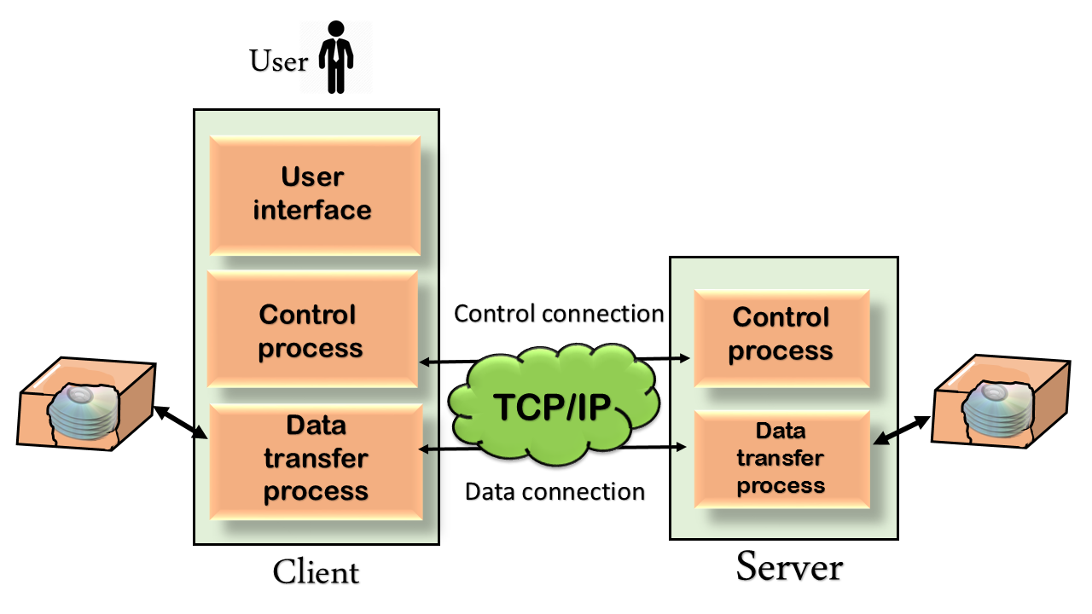
The above figure shows the basic model of the FTP. The FTP client has three components: the user interface, control process, and data transfer process. The server has two components: the server control process and the server data transfer process.
There are two types of connections in FTP:
- Control Connection: The control connection uses very simple rules for communication. Through control connection, we can transfer a line of command or line of response at a time. The control connection is made between the control processes. The control connection remains connected during the entire interactive FTP session.
- Data Connection: The Data Connection uses very complex rules as data types may vary. The data connection is made between data transfer processes. The data connection opens when a command comes for transferring the files and closes when the file is transferred.

FTP Clients
- FTP client is a program that implements a file transfer protocol which allows you to transfer files between two hosts on the internet.
- It allows a user to connect to a remote host and upload or download the files.
- It has a set of commands that we can use to connect to a host, transfer the files between you and your host and close the connection.
- The FTP program is also available as a built-in component in a Web browser. This GUI based FTP client makes the file transfer very easy and also does not require to remember the FTP commands.

Telnet
- The main task of the internet is to provide services to users. For example, users want to run different application programs at the remote site and transfer a result to the local site. This requires a client-server program such as FTP, SMTP. But this would not allow us to create a specific program for each demand.
- The better solution is to provide a general client-server program that lets the user access any application program on a remote computer. Therefore, a program that allows a user to log on to a remote computer. A popular client-server program Telnet is used to meet such demands. Telnet is an abbreviation for Terminal Network.
- Telnet provides a connection to the remote computer in such a way that a local terminal appears to be at the remote side.

There are two types of login:

Local Login

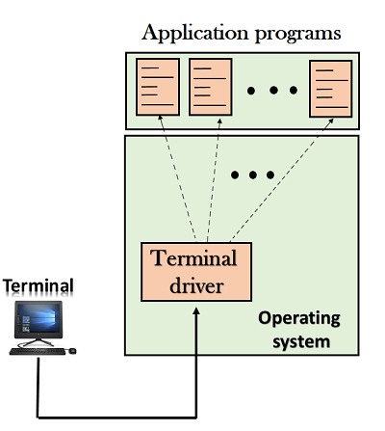

When a user logs into a local computer, then it is known as local login.

When the workstation running terminal emulator, the keystrokes entered by the user are accepted by the terminal driver. The terminal driver then passes these characters to the operating system which in turn, invokes the desired application program.

However, the operating system has special meaning to special characters. For example, in UNIX some combination of characters has special meanings such as control character with "z" means suspend. Such situations do not create any problem as the terminal driver knows the meaning of such characters. But, it can cause the problems in remote login.

Remote login
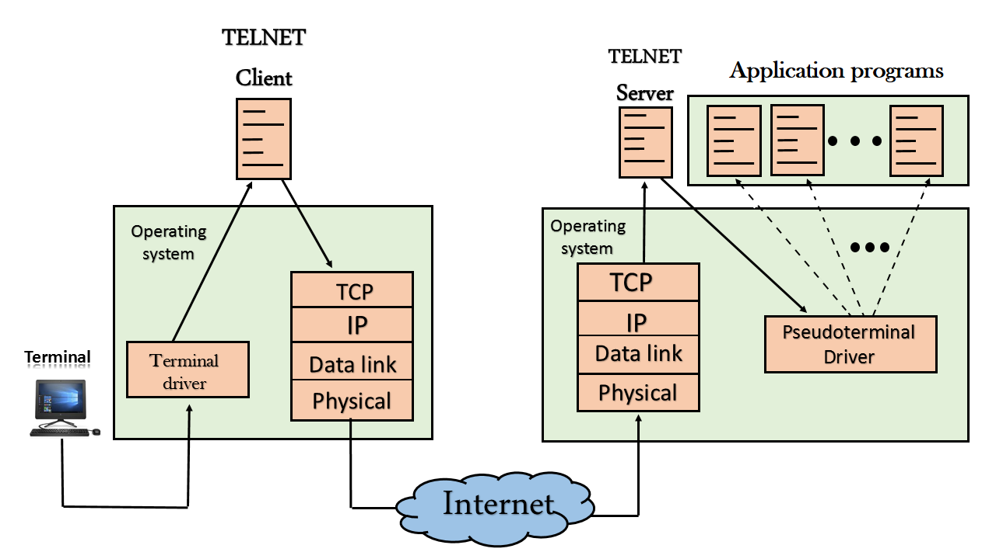
  - When the user wants to access an application program on a remote computer, then the user must perform remote login.

How remote login occurs

At the local site
The user sends the keystrokes to the terminal driver, the characters are then sent to the TELNET client. The TELNET client which in turn, transforms the characters to a universal character set known as network virtual terminal characters and delivers them to the local TCP/IP stack

At the remote site
The commands in NVT forms are transmitted to the TCP/IP at the remote machine. Here, the characters are delivered to the operating system and then pass to the TELNET server. The TELNET server transforms the characters which can be understandable by a remote computer. However, the characters cannot be directly passed to the operating system as a remote operating system does not receive the characters from the TELNET server. Therefore it requires some piece of software that can accept the characters from the TELNET server. The operating system then passes these characters to the appropriate application program.

SMTP
- SMTP stands for Simple Mail Transfer Protocol.
- SMTP is a set of communication guidelines that allow software to transmit an electronic mail over the internet is called Simple Mail Transfer Protocol.
- It is a program used for sending messages to other computer users based on e-mail addresses.
- It provides a mail exchange between users on the same or different computers, and it also supports:
  - It can send a single message to one or more recipients.
  - Sending message can include text, voice, video or graphics.
  - It can also send the messages on networks outside the internet.
- The main purpose of SMTP is used to set up communication rules between servers. The servers have a way of identifying themselves and announcing what kind of communication they are trying to perform. They also have a way of handling the errors such as incorrect email address. For example, if the recipient address is wrong, then receiving server reply with an error message of some kind.

Components of SMTP
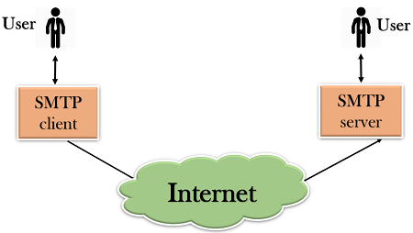
- First, we will break the SMTP client and SMTP server into two components such as user agent (UA) and mail transfer agent (MTA). The user agent (UA) prepares the message, creates the envelope and then puts the message in the envelope. The mail transfer agent (MTA) transfers this mail across the internet.
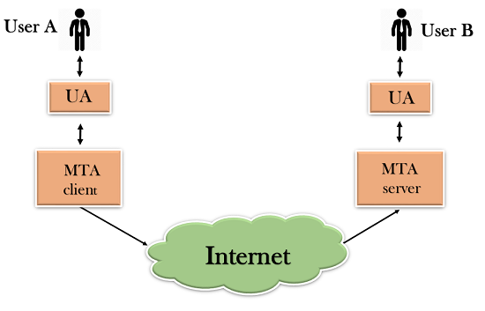
- SMTP allows a more complex system by adding a relaying system. Instead of just having one MTA at sending side and one at receiving side, more MTAs can be added, acting either as a client or server to relay the email.
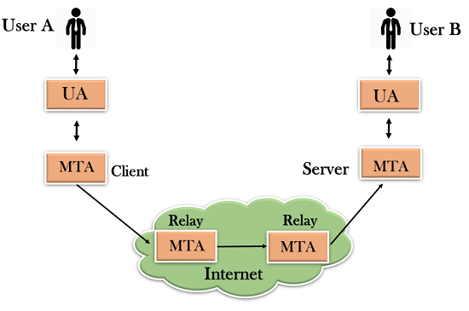
- The relaying system without TCP/IP protocol can also be used to send the emails to users, and this is achieved by the use of the mail gateway. The mail gateway is a relay MTA that can be used to receive an email.
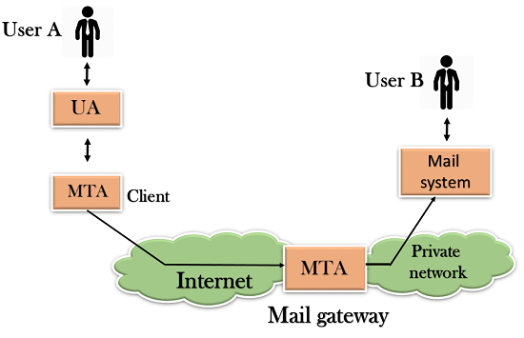

Working of SMTP
- Composition of Mail: A user sends an e-mail by composing an electronic mail message using a Mail User Agent (MUA). Mail User Agent is a program which is used to send and receive mail. The message contains two parts: body and header. The body is the main part of the message while the header includes information such as the sender and recipient address. The header also includes descriptive information such as the subject of the message. In this case, the message body is like a letter and header is like an envelope that contains the recipient's address.
- Submission of Mail: After composing an email, the mail client then submits the completed e-mail to the SMTP server by using SMTP on TCP port 25.
- Delivery of Mail: E-mail addresses contain two parts: username of the recipient and domain name. For example, vivek@gmail.com, where "vivek" is the username of the recipient and "gmail.com" is the domain name.
If the domain name of the recipient's email address is different from the sender's domain name, then MSA will send the mail to the Mail Transfer Agent (MTA). To relay the email, the MTA will find the target domain. It checks the MX record from Domain Name System to obtain the target domain. The MX record contains the domain name and IP address of the recipient's domain. Once the record is located, MTA connects to the exchange server to relay the message.
- Receipt and Processing of Mail: Once the incoming message is received, the exchange server delivers it to the incoming server (Mail Delivery Agent) which stores the e-mail where it waits for the user to retrieve it.
- Access and Retrieval of Mail: The stored email in MDA can be retrieved by using MUA (Mail User Agent). MUA can be accessed by using login and password.

SNMP
- SNMP stands for Simple Network Management Protocol.
- SNMP is a framework used for managing devices on the internet.
- It provides a set of operations for monitoring and managing the internet.

SNMP Concept
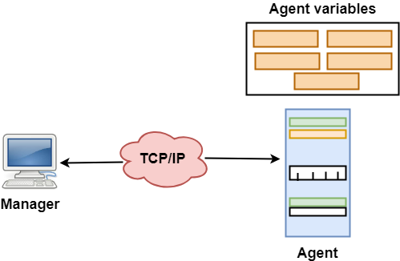
- SNMP has two components Manager and agent.
- The manager is a host that controls and monitors a set of agents such as routers.
- It is an application layer protocol in which a few manager stations can handle a set of agents.
- The protocol designed at the application level can monitor the devices made by different manufacturers and installed on different physical networks.
- It is used in a heterogeneous network made of different LANs and WANs connected by routers or gateways.

Managers & Agents
- A manager is a host that runs the SNMP client program while the agent is a router that runs the SNMP server program.
- Management of the internet is achieved through simple interaction between a manager and agent.
- The agent is used to keep the information in a database while the manager is used to access the values in the database. For example, a router can store the appropriate variables such as a number of packets received and forwarded while the manager can compare these variables to determine whether the router is congested or not.
- Agents can also contribute to the management process. A server program on the agent checks the environment, if something goes wrong, the agent sends a warning message to the manager.

Management with SNMP has three basic ideas:
- A manager checks the agent by requesting the information that reflects the behavior of the agent.
- A manager also forces the agent to perform a certain function by resetting values in the agent database.
- An agent also contributes to the management process by warning the manager regarding an unusual condition.

Management Components
- Management is not achieved only through the SNMP protocol but also the use of other protocols that can cooperate with the SNMP protocol. Management is achieved through the use of the other two protocols: SMI (Structure of management information) and MIB(management information base).
- Management is a combination of SMI, MIB, and SNMP. All these three protocols such as abstract syntax notation 1 (ASN.1) and basic encoding rules (BER).
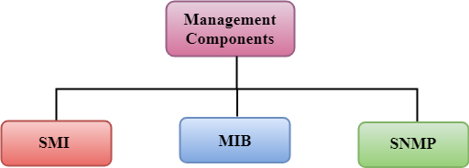

SMI
The SMI (Structure of management information) is a component used in network management. Its main function is to define the type of data that can be stored in an object and to show how to encode the data for the transmission over a network.

MIB
- The MIB (Management information base) is a second component for the network management.
- Each agent has its own MIB, which is a collection of all the objects that the manager can manage. MIB is categorized into eight groups: system, interface, address translation, ip, icmp, tcp, udp, and egp. These groups are under the mib object.
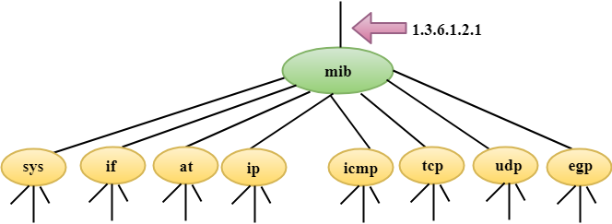

SNMP
SNMP defines five types of messages: GetRequest, GetNextRequest, SetRequest, GetResponse, and Trap.
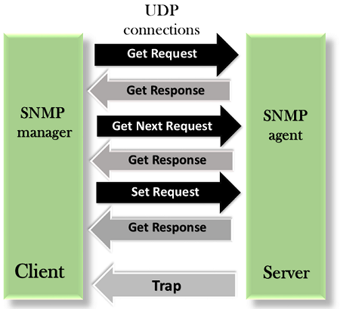
GetRequest: The GetRequest message is sent from a manager (client) to the agent (server) to retrieve the value of a variable.
GetNextRequest: The GetNextRequest message is sent from the manager to agent to retrieve the value of a variable. This type of message is used to retrieve the values of the entries in a table. If the manager does not know the indexes of the entries, then it will not be able to retrieve the values. In such situations, GetNextRequest message is used to define an object.
GetResponse: The GetResponse message is sent from an agent to the manager in response to the GetRequest and GetNextRequest message. This message contains the value of a variable requested by the manager.
SetRequest: The SetRequest message is sent from a manager to the agent to set a value in a variable.
Trap: The Trap message is sent from an agent to the manager to report an event. For example, if the agent is rebooted, then it informs the manager as well as sends the time of rebooting.

HTTP
- HTTP stands for HyperText Transfer Protocol.
- It is a protocol used to access the data on the World Wide Web (www).
- The HTTP protocol can be used to transfer the data in the form of plain text, hypertext, audio, video, and so on.
- This protocol is known as HyperText Transfer Protocol because of its efficiency that allows us to use in a hypertext environment where there are rapid jumps from one document to another document.
- HTTP is similar to the FTP as it also transfers the files from one host to another host. But, HTTP is simpler than FTP as HTTP uses only one connection, i.e., no control connection to transfer the files.
- HTTP is used to carry the data in the form of MIME-like format.
- HTTP is similar to SMTP as the data is transferred between client and server. The HTTP differs from the SMTP in the way the messages are sent from the client to the server and from server to the client. SMTP messages are stored and forwarded while HTTP messages are delivered immediately.

HTTP Transactions

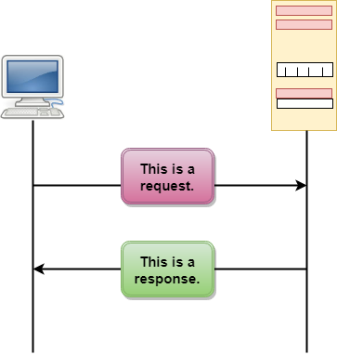
The above figure shows the HTTP transaction between client and server. The client initiates a transaction by sending a request message to the server. The server replies to the request message by sending a response message.

Messages
HTTP messages are of two types: request and response. Both the message types follow the same message format.
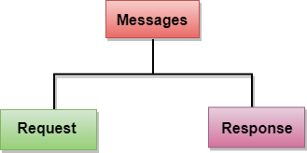
Request Message: The request message is sent by the client that consists of a request line, headers, and sometimes a body.
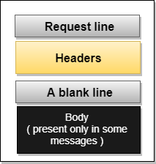
Response Message: The response message is sent by the server to the client that consists of a status line, headers, and sometimes a body.
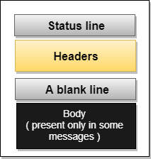

Uniform Resource Locator (URL)
- A client that wants to access the document in an internet needs an address and to facilitate the access of documents, the HTTP uses the concept of Uniform Resource Locator (URL).
- The Uniform Resource Locator (URL) is a standard way of specifying any kind of information on the internet.
- The URL defines four parts: method, host computer, port, and path.
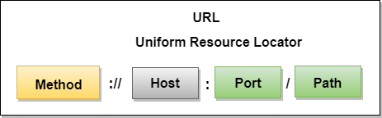
- Method: The method is the protocol used to retrieve the document from a server. For example, HTTP.
- Host: The host is the computer where the information is stored, and the computer is given an alias name. Web pages are mainly stored in the computers and the computers are given an alias name that begins with the characters "www". This field is not mandatory.
- Port: The URL can also contain the port number of the server, but it's an optional field. If the port number is included, then it must come between the host and path and it should be separated from the host by a colon.
- Path: Path is the pathname of the file where the information is stored. The path itself contains slashes that separate the directories from the subdirectories and files.

Cryptography
Cryptography, a word with Greek origins, means "secret writing." However, we use the term to refer to the science and art of transforming messages to make them secure and immune to attacks. Figure 30.1 shows the components involved in cryptography.
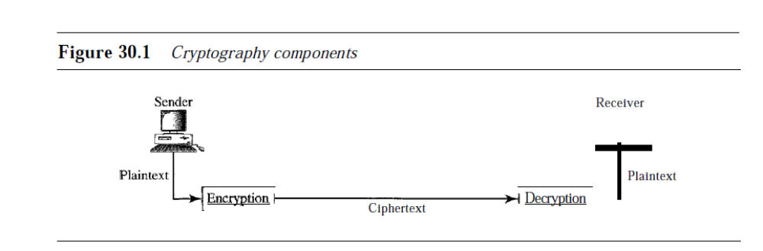
Plaintext and Ciphertext
The original message, before being transformed, is called plaintext. After the message
is transformed, it is called ciphertext. An encryption algorithm transforms the plaintext
into ciphertext; a decryption algorithm transforms the ciphertext back into plaintext.
The sender uses an encryption algorithm, and the receiver uses a decryption algorithm.
Cipher
We refer to encryption and decryption algorithms as ciphers. The term cipher is also used to refer to different categories of algorithms in cryptography. This is not to say that every sender-receiver pair needs their very own unique cipher for a secure communication.
On the contrary, one cipher can serve millions of communicating pairs.
Key
A key is a number (or a set of numbers) that the cipher, as an algorithm, operates on. To encrypt a message, we need an encryption algorithm, an encryption key, and the plaintext.
These create the ciphertext. To decrypt a message, we need a decryption algorithm, a decryption key, and the ciphertext. These reveal the original plaintext.
Two Categories
We can divide all the cryptography algorithms (ciphers) into two groups: symmetric key
(also called secret-key) cryptography algorithms and asymmetric (also called
public-key) cryptography algorithms. Figure 30.2 shows the taxonomy.
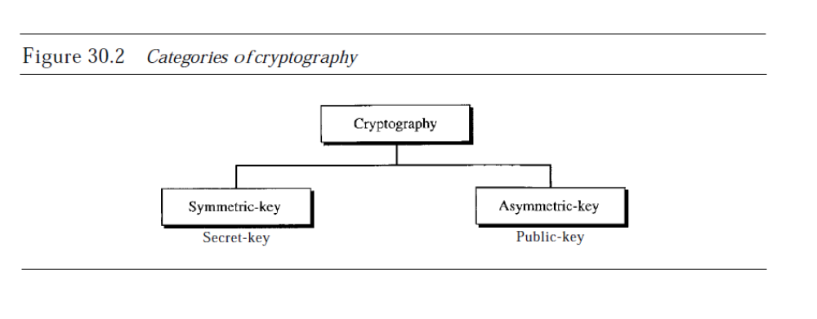
Symmetric·Key Cryptography
In symmetric-key cryptography, the same key is used by both parties. The sender uses
this key and an encryption algorithm to encrypt data; the receiver uses the same key and
the corresponding decryption algorithm to decrypt the data (see Figure 30.3).

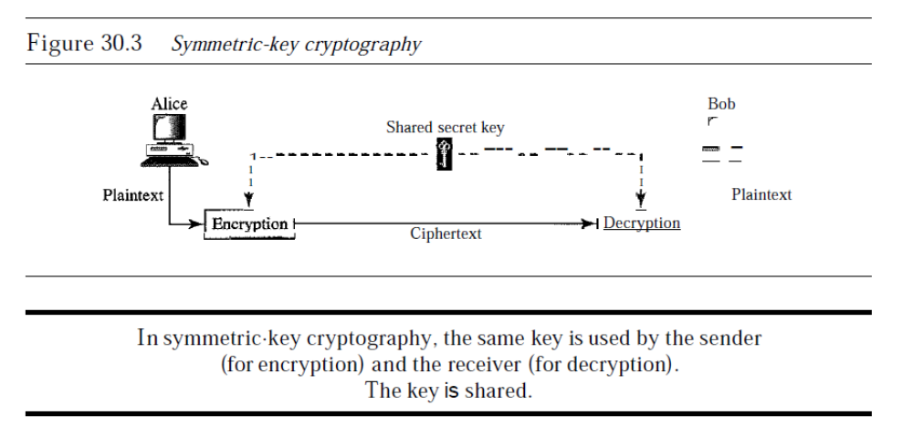
Asymmetric-Key Cryptography
In asymmetric or public-key cryptography, there are two keys: a private key and a public
key. The private key is kept by the receiver. The public key is announced to the public.
In Figure 30.4, imagine Alice wants to send a message to Bob. Alice uses the public key
to encrypt the message. When the message is received by Bob, the private key is used to
decrypt the message.
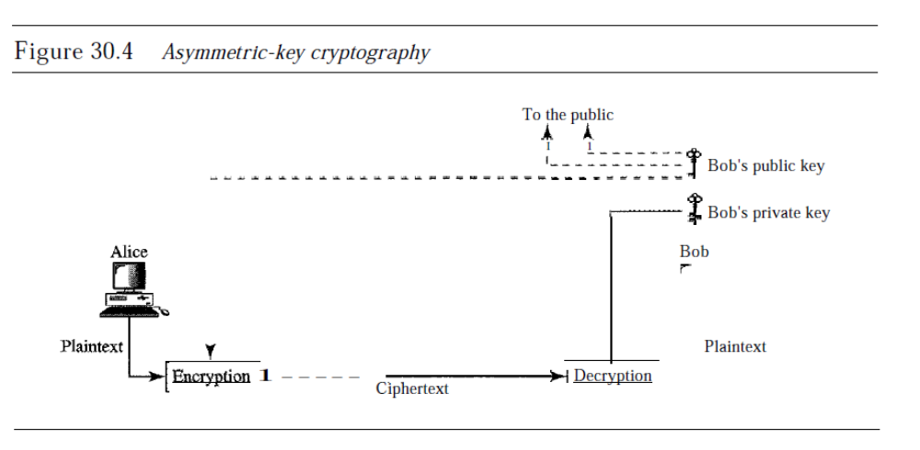
In public-key encryption/decryption, the public key that is used for encryption is
different from the private key that is used for decryption. The public key is available to
the public;' the private key is available only to an individual.

Firewall in Computer Network
A firewall is a network security device, either hardware or software-based, which monitors all incoming and outgoing traffic and based on a defined set of security rules it accepts, rejects or drops that specific traffic.
Accept : allow the traffic
Reject : block the traffic but reply with an “unreachable error”
Drop : block the traffic with no reply
A firewall establishes a barrier between secured internal networks and outside untrusted network, such as the Internet.

Generation of Firewall
Firewalls can be categorized based on its generation.
- First Generation- Packet Filtering Firewall: Packet filtering firewall is used to control network access by monitoring outgoing and incoming packet and allowing them to pass or stop based on source and destination IP address, protocols and ports. It analyses traffic at the transport protocol layer (but mainly uses first 3 layers).
Packet firewalls treat each packet in isolation. They have no ability to tell whether a packet is part of an existing stream of traffic. Only It can allow or deny the packets based on unique packet headers.

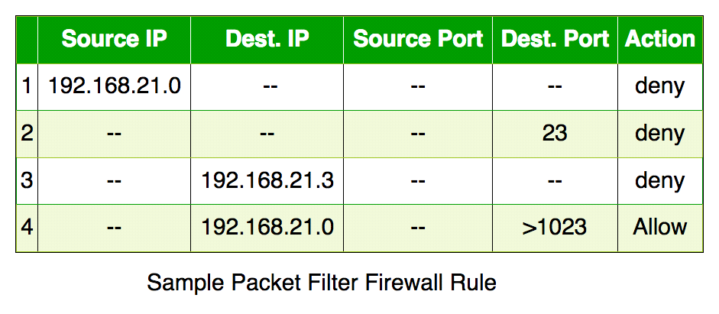
- Incoming packets from network 192.168.21.0 are blocked.
- Incoming packets destined for internal TELNET server (port 23) are blocked.
- Incoming packets destined for host 192.168.21.3 are blocked.
- All well-known services to the network 192.168.21.0 are allowed.
- Second Generation- Stateful Inspection Firewall: Stateful firewalls (performs Stateful Packet Inspection) are able to determine the connection state of packet, unlike Packet filtering firewall, which makes it more efficient. It keeps track of the state of networks connection travelling across it, such as TCP streams. So the filtering decisions would not only be based on defined rules, but also on packet’s history in the state table.

- Third Generation- Application Layer Firewall: Application layer firewalls are hosts that run proxy servers. A proxy firewall prevents the direct connection between either side of the firewall, each packet has to pass through the proxy. It can allow or block the traffic based on predefined rules.
Note: Application layer firewalls can also be used as Network Address Translator(NAT).
- Next Generation Firewalls (NGFW): Next Generation Firewalls are being deployed these days to stop modern security breaches like advance malware attacks and application-layer attacks. NGFW consists of Deep Packet Inspection, Application Inspection, SSL/SSH inspection and many functionalities to protect the network from these modern threats.

IP security (IPSec)

IP Sec (Internet Protocol Security) is an Internet Engineering Task Force (IETF) standard suite of protocols between two communication points across the IP network that provide data authentication, integrity, and confidentiality. It also defines the encrypted, decrypted, and authenticated packets. The protocols needed for secure key exchange and key management are defined in it.

Uses of IP Security
IPsec can be used to do the following things:
- To encrypt application layer data.
- To provide security for routers sending routing data across the public internet.
- To provide authentication without encryption, like to authenticate that the data originates from a known sender.
- To protect network data by setting up circuits using IPsec tunneling in which all data being sent between the two endpoints is encrypted, as with a Virtual Private Network(VPN) connection.

Components of IP Security
It has the following components:
- Encapsulating Security Payload (ESP)
- Authentication Header (AH)
- Internet Key Exchange (IKE)
1. Encapsulating Security Payload (ESP): It provides data integrity, encryption, authentication, and anti-replay. It also provides authentication for payload.
2. Authentication Header (AH): It also provides data integrity, authentication, and anti-replay and it does not provide encryption. The anti-replay protection protects against the unauthorized transmission of packets. It does not protect data confidentiality.
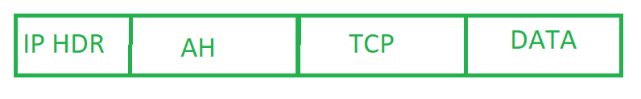
IP Header
3. Internet Key Exchange (IKE): It is a network security protocol designed to dynamically exchange encryption keys and find a way over Security Association (SA) between 2 devices. The Security Association (SA) establishes shared security attributes between 2 network entities to support secure communication. The Key Management Protocol (ISAKMP) and Internet Security Association provide a framework for authentication and key exchange.

Features of IPSec
- Authentication: IPSec provides authentication of IP packets using digital signatures or shared secrets. This helps ensure that the packets are not tampered with or forged.
- Confidentiality: IPSec provides confidentiality by encrypting IP packets, preventing eavesdropping on the network traffic.
- Integrity: IPSec provides integrity by ensuring that IP packets have not been modified or corrupted during transmission.
- Key management: IPSec provides key management services, including key exchange and key revocation, to ensure that cryptographic keys are securely managed.
- Tunneling: IPSec supports tunneling, allowing IP packets to be encapsulated within another protocol, such as GRE (Generic Routing Encapsulation) or L2TP (Layer 2 Tunneling Protocol).
.

Advantages of IPSec
- Strong security: IPSec provides strong cryptographic security services that help protect sensitive data and ensure network privacy and integrity.
- Wide compatibility: IPSec is an open standard protocol that is widely supported by vendors and can be used in heterogeneous environments.
- Flexibility: IPSec can be configured to provide security for a wide range of network topologies, including point-to-point, site-to-site, and remote access connections.
- Scalability: IPSec can be used to secure large-scale networks and can be scaled up or down as needed.
- Improved network performance: IPSec can help improve network performance by reducing network congestion and improving network efficiency.

Disadvantages of IPSec
- Configuration complexity: IPSec can be complex to configure and requires specialized knowledge and skills.
- Compatibility issues: IPSec can have compatibility issues with some network devices and applications, which can lead to interoperability problems.
- Performance impact: IPSec can impact network performance due to the overhead of encryption and decryption of IP packets.
- Key management: IPSec requires effective key management to ensure the security of the cryptographic keys used for encryption and authentication.
- Limited protection: IPSec only provides protection for IP traffic, and other protocols such as ICMP, DNS, and routing protocols may still be vulnerable to attacks.

